1. **Entrepreneurial in this new world**

1.1 date and time

Mon, December 30, 2022

5:00 PM – 6:00 PM

online event

free



1. Unravelling NFTs

2.1. Location

Muscat- Oman Convention & Exhibition Centre

Time: Tue, June 30, 9:00 AM

Price: 50 OMR

Refund policy



1. SEMINAR ON FINANCE FOR NON-FINANCE EXECUTIVES

Location: Muscat- Oman Convention & Exhibition Centre

Start Date: 14/06/2022 End Date: 18/06/2022 for 5 days

Time: 10:00 AM

No Refund policy

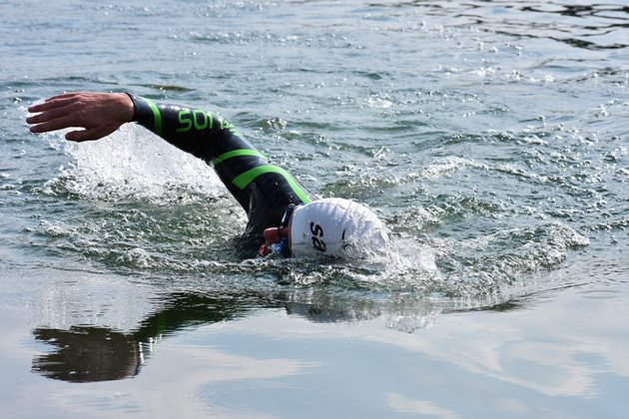

Sports and fitness

1. AQUATHLON CHALLENGE

Time: Fri Sep 2 2022 at 07:00 am

Sultan Qaboos Sports Complex, ,Muscat, Oman

Free



1. OMAN HEALTH By

Omanexpo LLC

**Date: 04 Oct 2022 - 06 Oct 2022**

**Time: 8.00 AM -9.00 PM**

**Location:** [**Oman International Exhibition Centre**](https://www.eventalways.com/oman-health#event-address)

Free entry

Food & Drink

1. Food & Hospitality Oman Muscat

Date:

26.09.2022 - 28.09.2022*

Monday - Wednesday, 3 days

Fair location:

Oman Convention & Exhibition Centre,

Al Maardih St, 111 Muscat, Muscat, Oman

Free entry

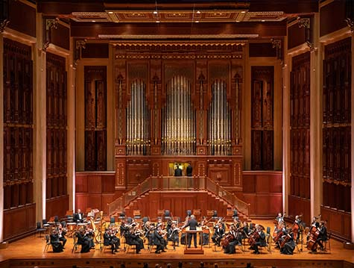Music

1. PIPE ORGAN CONCERT

PERFORMED BY THE ROYAL OMAN SYMPHONY ORCHESTRA AND MÜNCHNER KNABENCHOR

May 16 2022 7:30 PM

Prices:

Box: 160 OMR

Green : 35 OMR

Orange: 25 OMR

Blue: 20 OMR

Pink: 15 OMR

Gold: 45 OMR

Black: 10 OMR

5% VAT INCLUDED

Place : royal Opera House muscat

1. The Oman World Folk Music Festival

Dates: 16-7 to 20-7

Time: starts at 6.30 PM

Prices start at 15 OMR to 45 OMR

Location: ROHM, muscat

1. 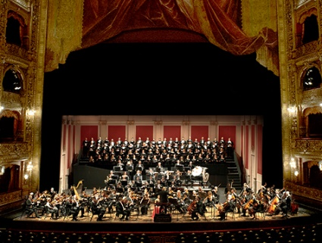BEETHOVEN’S NINTH SYMPHONY

PERFORMED BY THE ORCHESTRA AND CHOIR OF TEATRO COLÓN BUENOS AIRES CONDUCTED BY JOSÉ CURA

Time and date: September 13 2022 7:00 PM

Prices start at 15 OMR to 65 OMR

Location: ROHM, muscat

1. 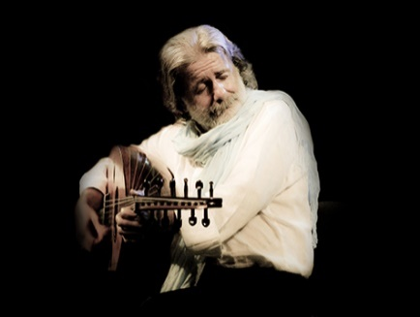MARCEL KHALIFE

Rinning time : September 26 2022 7:00 PM to September 27 2022 7:00 PM

Place : royal Opera House muscat

Prices starts at 25 OMR to 90 OMR